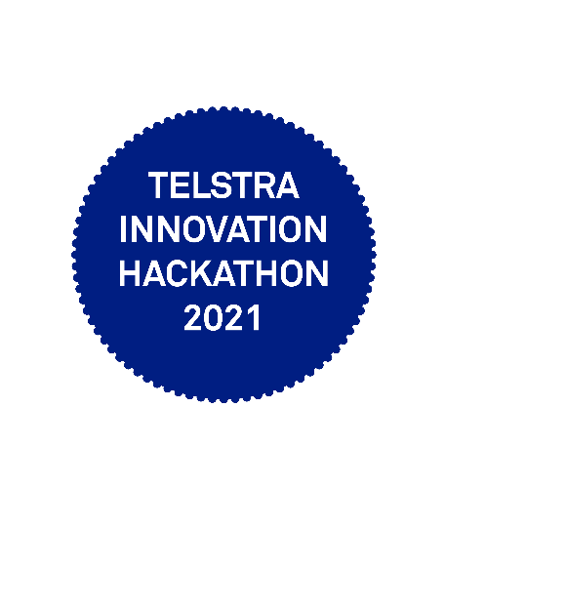

**Certificate of Achievement**

**People's Choice**

This certificate is presented to

Reema Yadav

of team **STARLET**, awarded **People's Choice** of the Telstra Innovation Hackathon 2021. Congratulations! Thank you for your contribution, as we work towards exceptional customer experiences, leading solutions and sustained growth.

**